**PIZZA SALES SQL QUERIES**

**A. KPI’s**

**1. Total Revenue:**

select sum(total_price) as Total_Revenue from pizza_sales

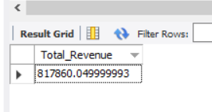

**2. Average Order Value:**

select sum(total_price) / count(distinct order_id) as Avg_order_value from pizza_sales

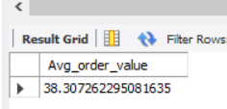

**3. Total Pizzas Sold:**

select sum(quantity) as Total_pizza_sold from pizza_sales

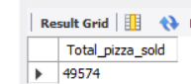

**4.** **Total Orders placed:**

select count(distinct order_id) as total_order_placed from pizza_sales

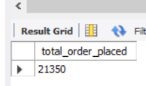

**5. Average Pizzas Per Order Value**

select cast((sum(quantity)*1.0)/(count(distinct order_id)*1.0) as decimal (10,2)) as avg_order_value

from pizza_sales

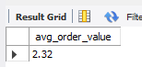

**B. Charts Requirement**

**1. Daily Order Trends:**

select date_format(cleaned_order_date, '%W') as order_day,

count(distinct order_id) as total_orders

from pizza_sales

group by date_format(cleaned_order_date, '%W');

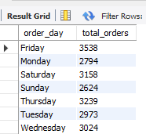

**2. Hourly Order Trends:**

select hour(str_to_date(order_time, '%H:%i:%s')) as order_hour ,

count(distinct order_id) as order_count

from pizza_sales

group by hour(str_to_date(order_time , '%H:%i:%s'))

order by hour(str_to_date(order_time , '%H:%i:%s')) ;

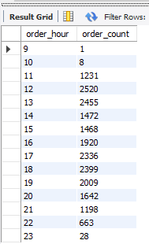

**3. Percentage of Sales by Pizza Category:**

select pizza_category,

cast(sum(total_price) as decimal(10,2)) as total_price,

cast(sum(total_price)*100 /(select sum(total_price) from pizza_sales ) as decimal(10,2)) as percentage_sales_by_category

from pizza_sales

group by pizza_category;

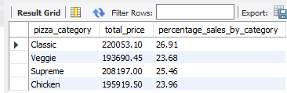

Note: to calculate month wise sales of pizza category

{select pizza_category, sum(total_price), (sum(total_price)*100 /(select sum(total_price) from pizza_sales where month(cleaned_order_date) = 1)) as percentage_sales_by_category

from pizza_sales

where month(cleaned_order_date) = 1

group by pizza_category;}

**4. Percentage of Sale by Pizza Size:**

select pizza_size,

cast(sum(total_price) as decimal(10,2)) as total_price,

cast(sum(total_price)*100/(select sum(total_price) from pizza_sales ) as decimal(10,2)) as percentage_sale_by_size

from pizza_sales

group by pizza_size;

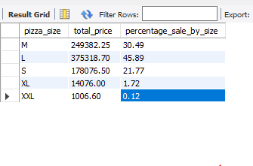

**5. Total Pizzas Sold By Pizza Category:**

select pizza_category , sum(quantity) as total_pizzas_sold

from pizza_sales

group by pizza_category;

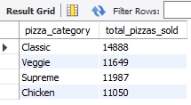

**6. Top 5 Sold Pizza:**

select pizza_name , sum(quantity) as most_pizza_sold

from pizza_sales

group by pizza_name

order by most_pizza_sold desc

limit 5;

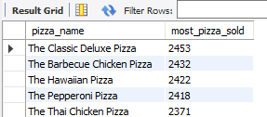

**6. Worst 5 Sold Pizza:**

select pizza_name , sum(quantity) as less_pizza_sold

from pizza_sales

group by pizza_name

order by less_pizza_sold asc

limit 5;

